
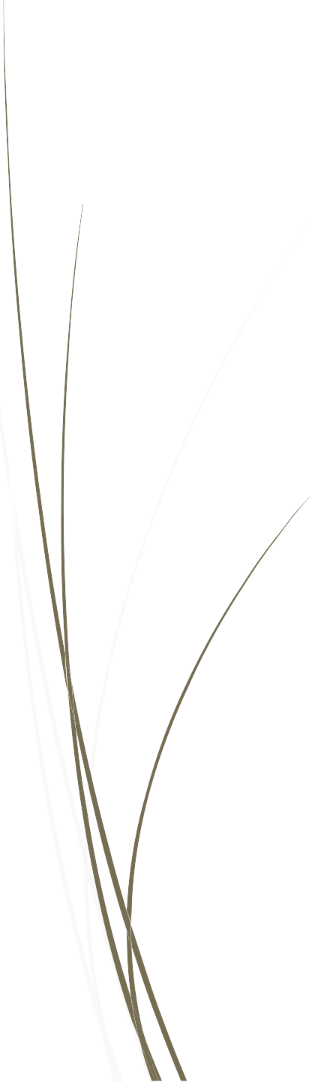
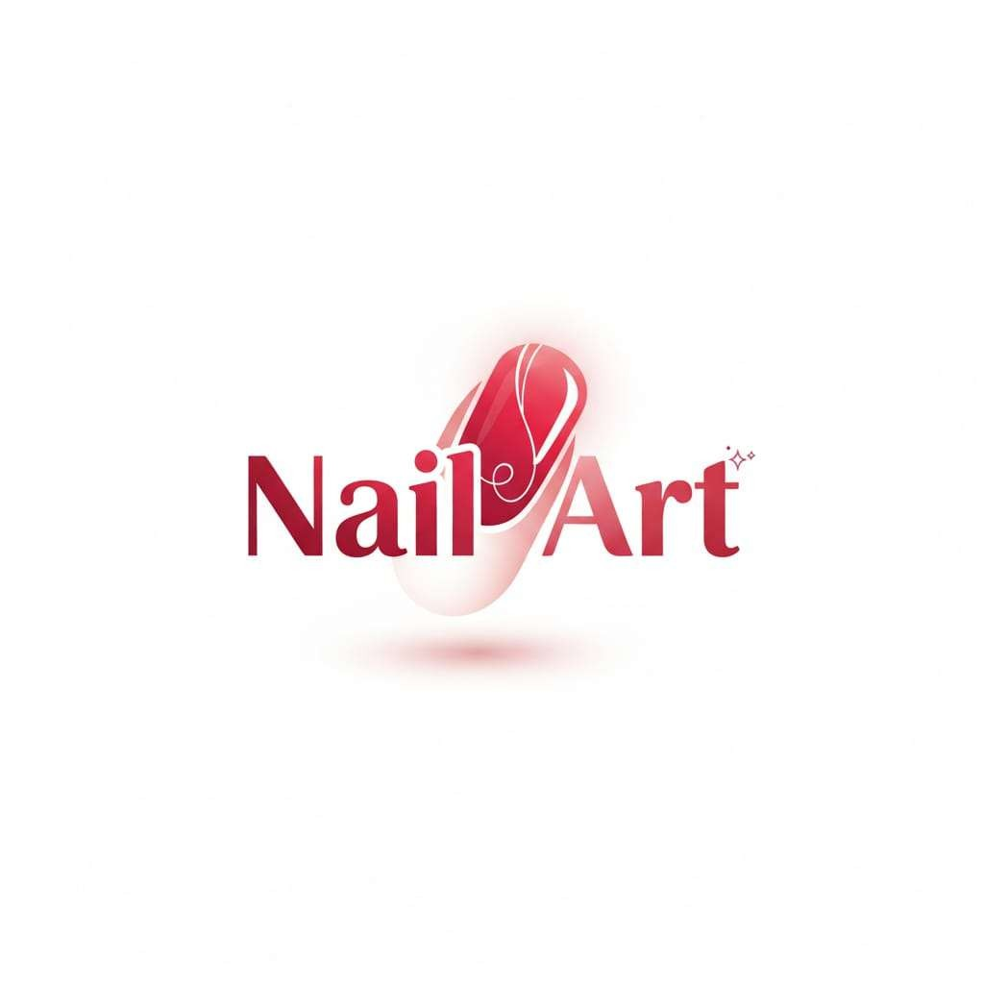
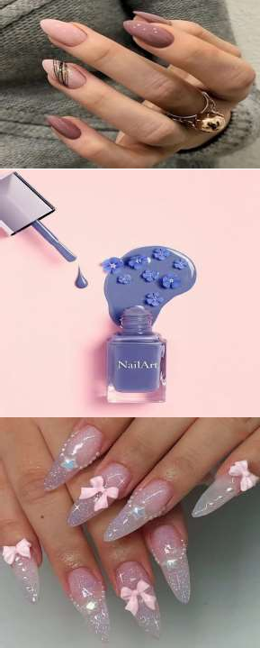
10/01/2026


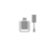
INTRODUCTION

Welcome to Nail Art Studio 💅 Where creativity meets elegance! Our Nail Art website is your ultimate destination for beautiful, trendy, and professional nail designs. We showcase a wide range of nail art styles—from simple and classy looks to bold and artistic creations— designed to suit every personality and occasion.

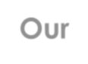

ABOUT US
Our Teammate's

Narand
Focused on designing in user-interface of the project.
(Pictures, Themes)
Haseeb
prepared and finalized the complete documentation for all projects

M. Minhal
Managed the overall project workflow.

TOOLS USED

HTML: For creating structure and layout. CSS: For styling the pages.

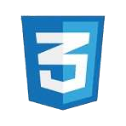


JavaScript: For adding interactivity and functionality in the website.
VS Code: utilized as the primary integrated development environment (IDE) for code development and management.

Bootstrap: Used Bootstrap as CSS framework for components.

Conclusion
- This project demonstrates the practical implementation of fundamental web development concepts. It effectively utilizes HTML, CSS, JavaScript, and Bootstrap to develop a real-world application. Additionally, the project establishes a scalable and maintainable foundation that supports future enhancements and expansion.



